

**Czech-Austrian Winter and Summer School**

**Liberalization and competition on the energy market in Czech Republic and Austria**

Mader, Georg

Matoušová, Hana

Co-operating Universities



Financial support by



**Prague and Vienna, 2011**

CONTENT

1. Introduction and General information 7

2. The way to a liberalized energy market in the Czech republic and Austria 7

3. The way to a liberalized gas market 10

4. The development of the energy market since liberalization 11

4.1. The gas market in Austria since the liberalization 11

4.2. The gas market in the Czech Republic since the liberalization 13

5. The electricity market since the liberalization 14

5.1 The composition of the electricity price in Austria and Czech Republic 14

5.2 The development of electricity price over the years 16

6. Conclusion 19

7. Literature 20

*Short after the year 2000 the energy market in Europe changed radically. There was a change from a very local regulated market to a totally liberalized market within some years. This paper should explain the reasons for this move and if and how the targets has been reached. A special focus is given on the price development of gas and electricity in Czech Republic and Austria. The text will explain why households haven’t benefitted from the liberalization while many companies have become much more competitive because of reducing their expenditures for energy.*

# 1. Introduction and General information

In former days in most European countries the energy market was a very local regulated matter. But by the European integration this changed more and more over the years. The aim of this liberalization of the energy market was to become more competitive on the international market. But was this really the case? Many criticisers are of the opinion that this aim has been reached but by the costs of the households. Other people were frightened that the security of supply wouldn’t be given for all people and regions. As we see not everybody was looking forward the liberalization. This text tries to explain what really happened. The main questions are how the price of gas and electricity, the most important fields of the energy market liberalization, has developed over the years and has the liberalization really been good for the customers? Furthermore the text will give an overview over the most important directives, which should abate the negative sides of a full liberalized market, for instance exploitation of the ecology by the suppliers to get more competitive, or disadvantages for customers. Also today’s criticisms are pointed out. In the beginning the text will show the way to the total liberalized market, which didn’t happen from one day to the other. In the following the developments of the gas and the electricity prices are shown, and how the price of gas and electricity is composed.

# 2. the way to a liberalized energy market in the czech republic and Austria

The energy markets in both countries haven’t been liberalized from one day to another. It was a long way to a fully liberalized market. In this chapter it will be explained what the reasons for this step, in a completely different direction, have been. To understand this easier it’s important to know when it happened and how liberalization happened. In the end of this chapter we go more into detail how far today’s energy market in the Czech Republic and Austria is liberalized.

The following is concerning both countries. The liberalization of the energy market in Austria and Czech Republic is very strong connected to the European integration. The working paper of the European Commission “The single market for Energy” came to the result that a non-integration of the isolated energy market would cost about 0,5% of the European Union GDP. To ensure the competitiveness of the European economy the target of the European Union was to give frameworks conditions for a fair competition of the European energy industry. The liberalisation of the energy market is divided into electricity and gas liberalization. The text starts with the electricity liberalization.[1]

|  |  |
| --- | --- |
| **The way to a liberalized electricity market**  Before liberalization, the electricity market was regulated and distributed by companies with governmental background. One reason for that was the fact of high costs of generating electricity because of the high part of fixed costs.[2] So it was secured that everyone who needs electricity, gets electricity.  In December 1996 the Directive 96/92/EC was passed to purpose the target of a single electricity market. Its aim has been to guarantee a competitive electricity market. There were huge discussions about the impact on the structure of supply. So there was even the discussion about the development of the prices for different customer groups after the liberalization. The fear that the battle for large customers could lead to disadvantages for the rest was very present. The background of this fear is the opinion that energy suppliers could, after losing a profitable customer, compensate their expected losses of turnover by raising the prices. This was opposed by the argument that the pressure on prices by the competition on the market would lead to a lower price level for all customers. [3]  It was sure that this makes only sense if cost transparency would be given. Another important point of this directive has been the common commitments for each power supplying company in the European Union which ensures security of supply, interests in environment protection and consumer protection.[4]  The European Commission decided for a progressive liberalization because of avoiding adaptive difficulties, which have been assumed by the integration of the directives in the national laws of the member states of the European Union. At the beginning, large customers with an annual consumption of more than 40 GWh got access to the liberalized market. Three years later the threshold was reduced to 20 GWh and further three years later to 9 GWh.[5]  To avoid unequal liberalization in European countries this has been regulated in Article 19(5) Directive 96/92/EC, which also regulates the running of the grids and the transparency of the competition. Article 17 of Directive 96/92/EC regulates the system of the grid access. The choice of the supplier is free for the customers and they are not bounded to the local supplier any more. One supplier can rent the grid to another supplier, but the terms of the transit have to be free negotiated.[6] |  |

**Facts about the liberalization of the electricity market in Austria and how the liberalized market is controlled**

Austria is forced by the European law to adopt this European Directive as the Czech Republic. So in 1998 Austria included this directive in the Elektrizitaetswirtschafts- und –organisationsgesetz („EIWOG 1998”), which means in English about Electricity Industry and Electricity Organisation law. The realization of the total liberalization was planned by the 1st October 2001. The government hoped for an enforcing effect for the competitiveness of local companies on the domestic market and on markets abroad. Because of the de-regularization of the old market, regularization of the new market was needed. Because of the fact that the electricity grid was still in a monopolistic situation, the entry to this have to be regulated. Furthermore it has been in the competence of the new regularization that the former monopolists cannot exploit their former market power position. To give this change of the market sense it was inevitable to avoid competitive distortion for instance by cross-subsidization and to ensure a transparent market to the customers. In the extension of the EIWOG 1998, the EIWOG II, it has also been included an environmental aspect. In the EIWOG II more subsidising of green alternative electricity has been guaranteed and also feed-in-tariffs has been regulated.[7]

After the liberalization also the supervision of the energy market has been new distributed. The agency which is responsible for monitoring the electricity market is the Energie-Control GmbH (E-Control), which on the other hand is monitored by the Minister of Economy and Labour and the E-Control Commission, which is an independent council, which is responsible for the general conditions of the grid operators. The commission also decides about appeals against decisions of the E-Control GmbH.[8]

The E-Control itself has monitoring and oversight function. It can enforce its conveyed tasks by sovereignty. It is also integrated, as the Austrian representative, by international collaborations concerning energy. E-Control also does public relations which helps to make disadvantages and advantages of the market liberalization transparent.[9]

**Facts about the liberalization of the electricity market in the Czech Republic and how the liberalized market is controlled**

Directive 96/92/EC was incorporated into Czech law in 2000. Directive 458/2000 scheduled a market opening into a few phases. In the first phase it was opened only to the biggest customers. EU Directive 2003/54/EC commanded European countries to open electricity market for all users till July 2007. The Czech Republic met the duty to 1st of January 2006.

The table 1 shows the count of Point of Deliveries (PoD) where was finished a process of supplier change:

|  |  |  |  |  |  |  |  |  |  |
| --- | --- | --- | --- | --- | --- | --- | --- | --- | --- |
| Year | 2003 | 2004 | 2005 | 2006 | 2007 | 2008 | 2009 | 2010 | 2011 (till the end of May) |
| # | 16 | 399 | 3 511 | 13 150 | 46 016 | 57 689 | 96 744 | 249 181 | 204 142 |

*Table 1: Supplier changes in electricity market in CZ 2003-2011 Source: www.ote-cr.cz*

We can see that hundreds of thousands users took advantage of the option. The process of supplier change takes three months and new supplier handles it.

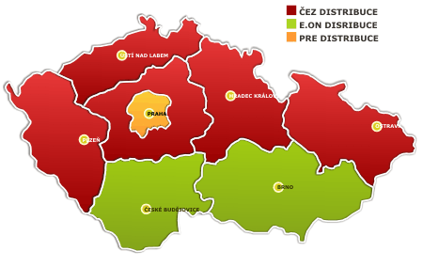

There is one company operating Transmission System of the Czech Republic (CEPS). Its task is to ensure electricity transmission and balance between electricity generation and consumption, as well as for gas infrastructure.

There are three main distribution systems operators (ČEZ, E.ON, PRE).

An administrative authority for regulation in the energy sector is The Energy Regulatory Office (ERÚ). For electricity market and gas sector as well.

# 3. The way to a liberalized gas market

Now the text gives a short overview of another important energy source, gas.

**Facts about the liberalization of the gas market in Austria and how the liberalized market is controlled**

The regulation of the Austrian gas market was originally regulated by the electricity law of 1938 which has been amended in 1948 for gas supply. Since the implementation of the European single market for natural gas, the complete gas law has been regulated by the “Gaswirtschaftsgesetz 2000”, called GWG (in English gas economy law). As the electricity market, even the gas market has been changed by the accession to the European Union. A huge step to the liberalization has been Directive 98/30/EG, which has ensured transparency of prices and the transit of gas. Directive 98/30/EG has to be incorporated to the national law of the member states until 10th of August 2000. The reason for this movement on the European gas market was the same as on the electricity market; to guarantee cheap gas in favour to the competitiveness.[10]

Directive 98/30/EG was included in Austria in 2000, by the Gaswirtschaftsgesetz 2000 (GWG I), in English Gas Economy Law. GWG I has included the way of double-stage market liberalization until October 2002.[11]

In the first period customers, who used more than 25m³ gas the year before, have been included in the liberalized gas market.[12]

There have been some problems by GWG I, so GWG II was introduced in 2002. GWG II has had a special focus on unbundling, network access; reasons for refusal of the use of the grid, damage claim by unjustified refusal of using the grid, transparency of the grid occupancy rate, fee using the grid respectively controlled network access, take-or-pay-contracts, organisational technique framework conditions and the responsibility of the regulation authority, which is the Energie-Control GmbH (E-Control), the same as on the electricity market.[13]

**Facts about the liberalization of the gas market in the Czech Republic**

The Czech Republic has essentially no own natural gas resources. It therefore has to import almost all of this energy source. For historical reasons, it bought almost all its natural gas from Russia (85%); however, in 1997 a contract with a consortium of Norwegian firms was concluded. Following EU directives, in 2005 the Czech authorities have started to open up the market allowing the 35 largest consumers to choose their supplier and extended this option to all non-household consumers in 2006 and household consumers in 2007.

|  |  |  |  |  |  |  |  |
| --- | --- | --- | --- | --- | --- | --- | --- |
| Year | 2005 | 2006 | 2007 | 2008 | 2009 | 2010 | 2011 (till the end of May) |
| # | 2 | 454 | 6699 | 596 | 33327 | 84424 | 100324 |

*Table 2: Supplier changes in gas sector in CZ 2005 – 2011 Source: www.ote-cr.cz*

The table 2 shows that the opening of gas market is a little bit slower than the electricity market. Till May 2011 the total amount of changes was 225 000, i.e. 7,8 % of all consumers. The biggest skip came in the period January 2010 – May 2011. Not only almost 200000 changes happened but also the number of suppliers increased from 8 to 25.

# 4. The development of the energy market since liberalization

In general it could be said, that the liberalization of the energy market has had influence on the gas and electricity market. The market of renewable energy was not really developed before the liberalization and so there it would be very hard to compare today’s market with the market before the liberalization. It is to mention that the directives which has regulated the European energy market has enforced the share of renewable energy sources.

## 4.1. The gas market in Austria since the liberalization

In Austria the gas market has been liberalized until 2002 step by step. It is not unimportant do understand how the price in Austria emerge. So the following tries to explain this.

**The composition of the gas price in Austria**

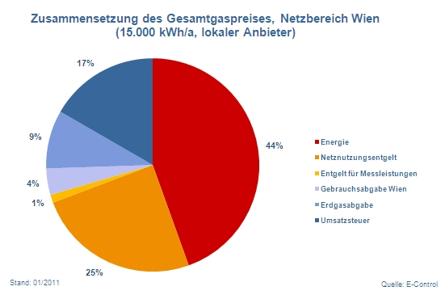

*Graph 1: Composition of the complete gas price in the grid area Vienna. (15,000 kWh/a, local supplier). Red: Energy, orange: grid using charge, yellow: charge for measuring, grey: using tax Vienna, light blue: natural gas tax, dark blue: sales tax. Source: E-control*

Graph 1 shows the composition of the gas price for Vienna on the example of a local supplier. As we can see not even the half of the price is for the commodity itself. Gas itself has only a share of the price of 44%. The allowance to use the grid is responsible for a share of 25%, which is more than the half of the gas share. 17% is the sales tax and 9% is for a tax on gas. The share of 5% which is rest, represents a tax for using and a charge for measuring.[14]

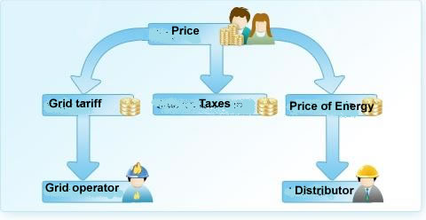

*Fig.2: The distribution of the gas price.*

*Source: E-Control*

The price of energy is the price which the gas distributor gets for the product. In the liberalized Austrian gas market the distributors (suppliers) are in competition and the price is determined by each distributor itself. The grid tariffs get the grid operator. Its price isn’t determined by the supplier, it is determined by Energie-Control Austria, the responsible controlling authority.[15]

**The development of gas price over the years**

Graph 2 shows the development of the Price Index for gas since January 2001. The base year is 2002, in which the gas market was totally liberalized.

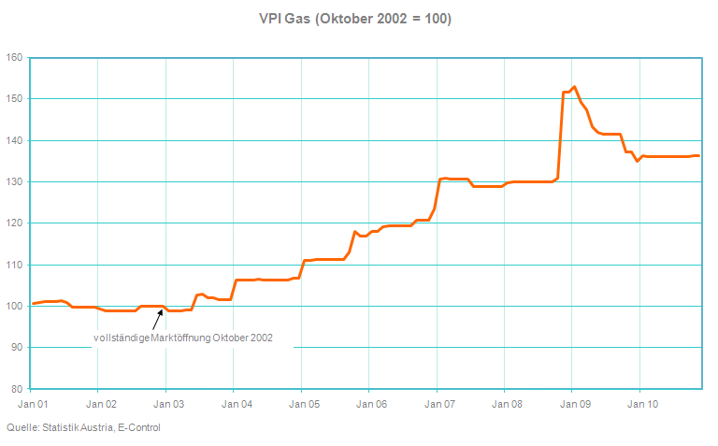

*Graph 2: Price Index of gas with the October 2002 as base (October 2002=100). All taxes and subsidies are included. Source:E-Control*

In the first years after the liberalization the price development of the gas price was rather constant, and then the price has started rising constantly. When the European economy was hit by the depression, the price raised enormous by over 15% only in one month. In the phase of recovery of the economy the price sunk by about 15% in one year.[16] To make the interpretation of graph 2 easier, it is to mention that the average inflation in Austria from 2001 to 2010 has been 1.94%. In the years of the main crisis, 2007 and 2008, the average inflation in Austria was 2.7%. In 2008 inflation was 3.2%. In 2009 the inflation was only 0.5% and in 2010 it was about 1.8%.[17] The price for gas is nearly as vulnerable like oil, because the price reacts very strong on political crisis in countries which are important in gas exploration and delivery and on the development of economies.

**The reasons for the increasing gas price since 2002**

As we have seen in graph 2 the price of gas increased since the liberalization. For sure it is not possible to blame the market liberalization alone for this price increase. The price is also strong connected to political crisis and the development of the economy. But a research by the Austrian Energy Agceny (AEA) for the Arbeiterkammer, in English Official Representation of Employees, blamed the energy suppliers in a very strong way. The AEA did researches by eleven gas suppliers in Austria between July 2008 and June 2010. They compared the gas prices for the households and the trade price for gas. The trade price for gas has fallen by about 1/5 between July 2008 and June 2010 but the gas prices for the household have risen by about 5%. Only some Austrian suppliers have sunk their prices, most increased the prices. For instance TIGAS natural gas Tyrol has increased their prices by 22%. The AEA has interpreted their result that the market liberalization and the free pricing give not the promised advantage to the customers. On the other hand customers compare the different prices of the suppliers not enough, which would be very important for the competition on the market an in the following for the price development. As the reader can see also the passing of prices doesn’t work.[18]

## 4.2. The gas market in the Czech Republic since the liberalization

Czech energy regular (ERO) has declared a series of decrees, describing the rules for the organization of the gas market and its gradual opening. In order to ensure transparency and equal conditions, the former monopoly is obliged to legally unbundle. This step ensures a clear separation of the activities of system operators and the traders. The competition among traders should reduce the price of gas for the final consumers and provide more equal profit opportunities for all companies and reduce prices for final customers.

From January 2006 all consumers except householders were considered as eligible customers, so they can choose their supplier. Householders were regarded as captive customers, that are served by the former monopoly and the price of gas supplied to them is regulated by ERO. But the process of opening the market was not as expected and there were no new natural gas suppliers. Prices for eligible customers have significantly increased. Due to these facts, in the beginning of 2006 the ERO re-introduced regulation of prices even for eligible customers.

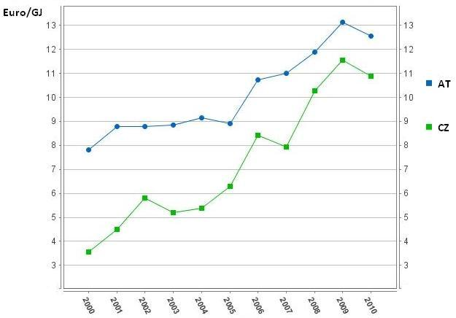

*Graph 3: Gas prices in CZ and AT in the period 2000-2010 Source: Eurostat*

The development of gas price in the Czech Republic is fairly analogous to Austrian market. The price of gas in the Czech Republic increased threefold in the period 2000-2010 as you can see in the graph 3.

# 

# 5. the electricity market since the liberalization

Here the text focuses on the second form of energy, which has played a central role in the European market liberalization, electricity. The electricity market in Austria is complete liberalized since first of October 2001. In the Czech Republic it is since January 2006.

## 5.1 The composition of the electricity price in Austria and Czech Republic

To understand the development of prices of electricity, it is valuable to look at their composition. Comparing Austrian and Czech prices the share of taxes is considerably higher in Austria. In 2010 electricity price paid by end-users was formed from 28% by all taxes (VAT included). In Czech Republic it was only 18%.

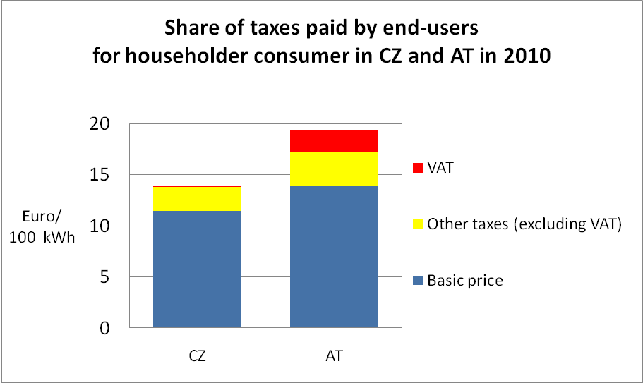

*Graph 4 Share of taxes paid by end-users in 2010 Source: Eurostat*

The electricity price in Austria consists of the price of the energy itself, the grid price and taxes. The following figure shows this on the example of a local supplier in Vienna.

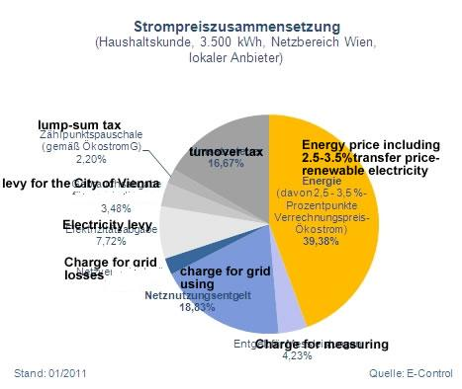

*Graph. 5: The composition of the electricity price, for household customers (3,500 kWh), on the example of a local supplier in Vienna Source: E-Control*

As we can see in this graph also on the Vienna electricity market itself the price for the customer consists only by 40% of the energy price itself. The rest are taxes and charges. The charge for the allowance to use the grid is over 18% and the turnover tax is 16.67%, the electricity levy is over 7% of the price. About 3.5% of the total price is a levy for the city of Vienna and the charge for grid losses make out over 2% of the price for electricity.[19]

In 2010 energy itself forms 42.3 % of electricity price in Czech Republic. Taxes were 17.4%, renewables and CHP 4.2 %. Distribution and transmission charges all together were 36.1%. More details in the graph 6.

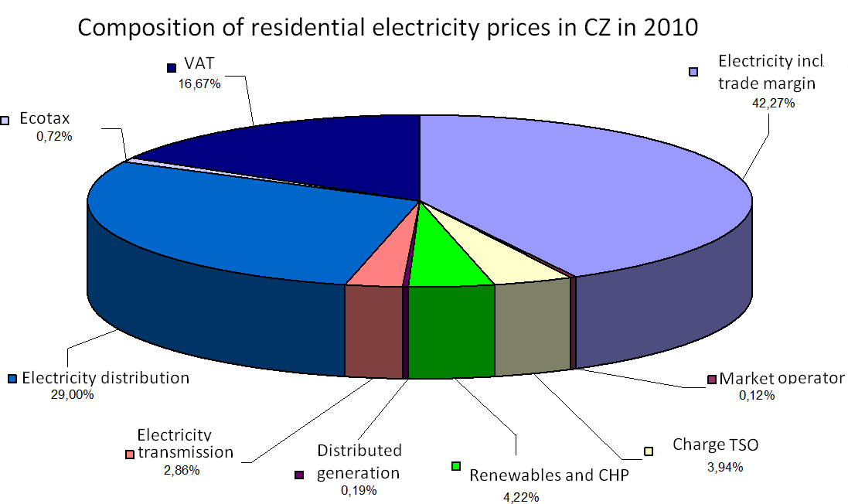

*Graph 6 Composition of residential electricity prices in CZ 2010 Source: ERU*

## 5.2 The development of electricity price over the years

As we see at figure 7 the prices in the AT were stagnating until 2006 and started to increase rapidly afterwards. Prices in the CZ were constantly increasing from the 0.05 Euro/kWh in 2000 to 0,11 Euro/kWh in 2010.

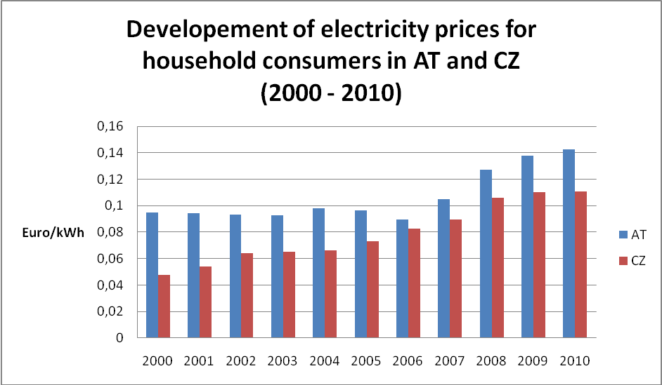

*Graph 7: Development of electricity prices for household consumers in AT and CZ Source: Eurostat*

Graph 8 shows the development of the Price Index for electricity since January 1999 in Austria. The base year is 2001, which is the year in which the electricity market was totally liberalized. In the figure the most important changes are mentioned.

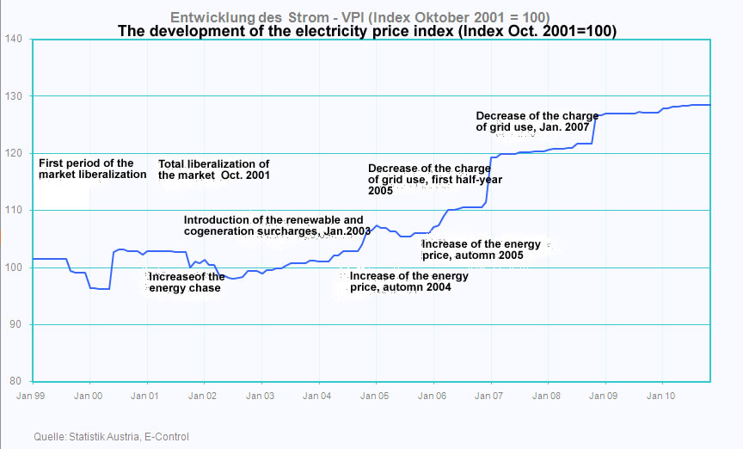

*Graph 8: The development of electricity price index since (VPI) since 1999 with October 2001 as the base Source: E-control*

The first phase of liberalization was in 1999. Short after the first opening of the market the price felt down. Before the market was liberalized totally the price rose very fast, but after these increases the price was rather resilient. In the end of 2001 the price felt by some percent. Over the following years the price was constantly increasing by some percent each year, without huge amplitudes. But in January 2007 and in November and December 2009 the price increased rapidly. Especially the increase in 2007 is not comprehensible because of a decrease of the grid charge. To compare with the inflation rates of the years, please have a look on 3.1.2. The price of the electricity hasn’t risen so vulnerable like the gas price.[20]

Situation of Czech Republic is described in the graph 9. Prices slightly increased in the period 1991-1997. The growth of electricity prices for residental users was lower than general inflation. Residental sector was cross subsidized by industrial sector. That was cutt off in 1999 by government desicion and fast growth occured between 1999 and 2002.

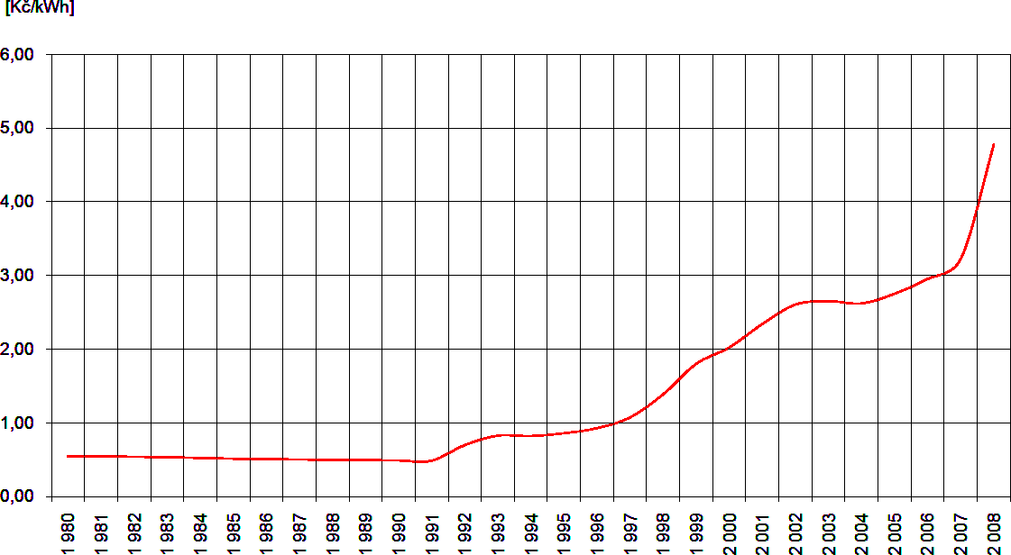

*Graph 9 The development of electricity prices in the CZ (1980 - 2008) Source: ERU*

## The reasons for the increasing electricity price

The Austrian Energy Agency, AEA, even researched the electricity market for the Arbeiterkammer (Official Representation of Employees). 14 electricity suppliers have been investigated by the AEA between July 2008 and June 2010. The electricity prices for households have been compared to trade price for electricity. While the prices raised by 5.5%, the trade price sunk by about 1/5. While the prices for electricity rose until January 2009 on the electricity stock exchange EEX in Leipzig, the price changes were relayed to the customers. But since June 2009 the prices have been falling, but these changes haven’t relayed to the households. Even here the argument is mentioned that the liberalization of the electricity market has not brought the promised positive aspects along. The AEA even here mentions that customers have to compare more the prices of the supplying companies and that the companies have to relay even the positive price developments to the customers.[21]

**The reactions after the liberalization**

One year after the liberalization of the electricity market and short after the liberalization of the gas market in Austria, Schneider and Mader of the University of Linz (AUT) published an empirical study about levies concerning the liberalization.

For their levy they asked 600 industrial companies, 150 electricity companies, 42 gas companies and 307 households.

15.5% of the companies have changed the electricity supplier after liberalization. All of these companies who changed the electricity supplier maintained that the change have brought along cost benefits for them. 37.5% of the companies which could have reached a markdown for electricity of about 30-40% have changed their supplier. Of these who only could reach 0-10% markdown, no company has changed.

In the following the reasons for the companies which didn’t change.

3.8% didn’t change because of insufficient information. 62.5% mentioned that they are satisfied with their current supplier. 45% mentioned “other reasons”. This could be, that the current supplier has had the best offer, no chance to change because of long-range contract commitment, or that they haven’t considered exactly with this issue.

59.8% of the companies obtained an offer even from abroad. Although this rate is high the market share of electricity supplying companies from abroad is rather low because the costs of transport of electricity in Austria are very high. Another reason is that many electricity supplying companies from abroad have shares on Austrian companies and so they have no incentives to take part of this competition. As we can see in Figure 5 after the first phase of electricity market liberalization the price was falling. Many companies mentioned that the prices sunk. 28% of the companies said that they could decrease their electricity expenditures by 20-30%.

When the samples where asked about the reasons for the decrease of the electricity price, 78.7% traced this to the increase of competition. 50.5% also mentioned the strong trade position of their company. 3.2% said that the decrease of electricity expenditures is also reasoned by the strong support of the WKO, The Austrian Federal Economic Chamber.[22]

# 6. Conclusion

When we take in mind the development of the gas and the electricity price, huge differences can be seen. While the price of the electricity increased more flat and constant the price of gas has some huge amplitude in its curve.

The gas price even increased more than the electricity price over the years. One reason for this is that the price for gas reacts very strong on political crisis, especially when these are connected with Russia. It has been seen that short after the liberalization of the electricity market customers had advantages which disappeared in the last years. The AEA pointed out that electricity and gas supplying companies have a huge information advantage which is even utilized by them. Here it is to mention that is the function of the controlling agency, in Austria E-Control, to minimize this advantage. So about one decade after the liberalization there are still monitoring problems. When we have a look on the price development it seems that this producer advantage increases especially in the last years. The raise of the prices could not only reasoned by inflation. There is still the problem that larger companies could profit much more from the liberalization of the energy market because they often have huge bargaining power, which households don’t have. So the price advantages of companies are often beard by the households, which indeed increases the competitiveness of European companies on the global market but on the other hand decreases the bargaining power of the households.

But is to mention that households have to compare the offers of the suppliers much more. As we have seen in the text companies could save a lot of money because of comparing and bargaining. But it is to mention that these huge saving rates were possible short after the liberalization where especially the electricity price was rather low.

There could only be a fair competition for customers and suppliers when consumers would be more informed. On the one hand this is the task of E-Control and on the opposite side customers have to do inform themselves more.

# 7. Literature

ARBEITERKAMMER ÖSTERREICH (2010), ARBEITERKAMMER.AT, 2010. <http://www.arbeiterkammer.at/online/strom-und-gaspreise-stark-gestiegen-56790.html>, Download on 24th of May 2011.

CEPS (2011), CEPS.CZ, 2011. <www.ceps.cz>, Downloaded on the 28th of May 2011.

Chemišinec I., M.Marvan, J.Nečesaný, T.Sýkora, J.Tůma: Obchod s elektřinou, 2010

E-CONTROL (2011), E-CONTROL.AT, 2011. <http://www.e-control.at/de/statistik/gas/marktstatistik/preisentwicklung>, Download on 28th of May 2011

E-CONTROL (2011), E-CONTROL.AT, 2011. <http://e-control.at/de/konsumenten/gas/der-gaspreis/preiszusammensetzung

>, Download on 28th of May 2011.

E-CONTROL (2011), E-CONTROL.AT, 2011.

<http://www.e-control.at/de/statistik/gas/marktstatistik/preisentwicklung>, Download on 28th of May 2011.

E-CONTROL (2011), E-CONTROL.AT, 2011.

<http://www.e-control.at/de/konsumenten/gas/der-gaspreis/gaspreis-monitor>, Download on 28th of May 2011.

E-CONTROL (2011), E-CONTROL.AT, 2011.

<http://www.e-control.at/de/statistik/strom/marktstatistik/preisentwicklung>, Download on 28th of May 2011.

E-CONTROL (2011), E-CONTROL.AT, 2011.

<http://www.e-control.at/de/statistik/strom/marktstatistik/preisentwicklung>, Download on 28th of May 2011.

ERU (2011), ERU.CZ, 2011. <www.eru.cz>, Downloaded on the 28th of May 2011

EUROSTAT (2011), EPP.EUROSTAT.EC, 2011. <ec.europa.eu/eurostat>, Downloaded on the 29th of May 2011.

INTERNATIONAL ENERGY AGANCY (IEA) (2011), IEA.ORG, 2011. <<http://www.iea.org/>>, Downloaded on the 26th of April 2011.

Knápek J., R.Haas, J.Jílková: Energy for Sustainable Development II, 2010

Mader S., Schneider F. (2002), Erhebung einer empirischen Erhebung zum Thema Energiemarktliberalisierung in Österreich. Energie Institut der Johannes Kepler Universität Linz.

Nemec, P., M. Brodey, H. Goldstein, K., A. P. Lütgendorf, S. Polster, R. Schanda, T. Schirmer, R. Schneider, N. Wiesinger, J. P. Willheim, G. Zeiler. Liberalisierung österreichischer Infrastrukturmarkt. 2003. Vienna:LexisNexis ARD Orac.

OTE CR (2011), OTE-CR.CZ, 2011. <www.ote-cr.cz>, Downloaded on the 28th of May 2011.

Schneider R. (2000), Analyse des österreichischen Energiemarktes: eine empirische Untersuchung über die Auswirkungen der Liberalisierung. Graz, Karl-Franzens-Univ., Dipl.-Arbeit, Graz.

STATISTIK AUSTRIA (2011), STATISTIK.AT, 2011. <<http://www.statistik.at/>>, Downloaded on the 26th of April 2011.

WIRTSCHAFTSKAMMER ÖSTERREICH (2011), WKO.AT, 2011, Stromanbieter in Österreich. 2011. <<http://portal.wko.at/wk/format_detail.wk?AngID=1&StID=276184>>, Downloaded on the 26th of April 2011.

[M. MRAVEC, Understanding the Failure (so far) of the Liberalization of the Czech Market in Natural Gas: some models](http://refgov.cpdr.ucl.ac.be/?go=publications&dc=115602da8c8b3939434fae5bfa28525545b11786)

1. Brodey, 2003, 42-43
2. Schneider, 2000, 25-30
3. Schneider, 2000, 28
4. Brodey, 2003, 43-44
5. Schneider, 2000, 39 und Art. 19(3) Directive 96/92/EC
6. Schneider, 2000, 40
7. Brodey, 2003, 42-50
8. Brodey, 2003, 49
9. Brodey, 2003, 49-50

   *Fig.1 Distribution system operators in CZ*

   *Source: http://www.heliaenergy.cz*
10. Schanda, 2003, 63-65
11. Schanda, 2003, 65-66
12. Schanda, 2003, 65-66
13. Schanda, 2003, 65-77
14. *<*http://www.e-control.at/de/statistik/gas/marktstatistik/preisentwicklung>, 28th of April 2011
15. *<http://e-control.at/de/konsumenten/gas/der-gaspreis/preiszusammensetzung>*
16. http://www.e-control.at/de/statistik/gas/marktstatistik/preisentwicklung
17. Wirtschaftskammer Österreich, http://www.wko.at/statistik/prognose/inflation.pdf
18. Arbeiterkammer, http://www.arbeiterkammer.at/online/strom-und-gaspreise-stark-gestiegen-56790.html
19. http://www.e-control.at/de/statistik/strom/marktstatistik/preisentwicklung
20. http://www.e-control.at/de/statistik/strom/marktstatistik/preisentwicklung
21. http://www.arbeiterkammer.at/online/strom-und-gaspreise-stark-gestiegen-56790.html
22. Mader, Schneider, 2002, 3-12